

**ABSTRACT:**

This project is very useful for the study of JavaScript and Cascading Style Sheet gives developers flexibility and is a more accessible framework for new developers since we can build a web application quickly using simple code.This project report consists of basic idea of MASS MAIL DISPATCHER for sending email . This project basically supports busy people who want to save the time. There is a easy interaction for the user to add email address, password, subject and body of mail.

This project accepts a .csv file and purifies the list emails to valid and invalid which will be displayed in one of the webpages. It finally sends mails to the valid set of mails by accepting input from user.

Table of content

1. Introduction
2. Existing methods
3. Proposed method with architecture
4. Methodology
5. Implementation
6. Conclusion

NAME: **MASS MAIL DISPATCHER**

**INTRODUCTION:**

A bulk email is a marketing message sent by a brand to multiple recipients at once.A mass mail dispatcher is a service that allows its users to send mail messages in bulk to multiple lists of recipients at a specified time.

**EXISTING METHODS:**

1. **USING A MAILING LIST SERVICE**

* The easiest and most reliable way to send mass email is to use a service that specializes in email marketing.

1. **USING A STANDARD EMAIL CLIENT**

* To send bulk mails, you can just add the addresses to the "BCC" field of the message header.

**PROPOSED METHOD**

This is implemented using HTML,CSS and JavaScript file.One HTML views are used one to accept csv file from the user, and to display valid and invalid mail id’s and also to send mails to the valid set of email id’s.

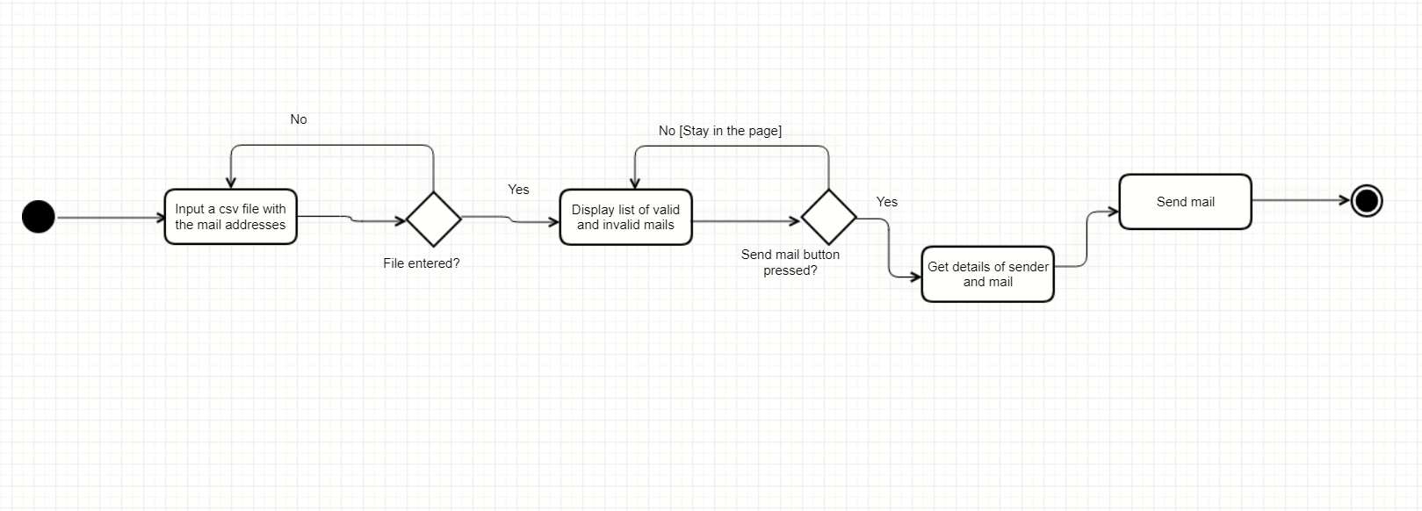**ARCHITECTURE**

activity diagram of the project

**METHODOLOGY**

The project is implemented using simple HTML code and CSS for frontend and JavaScript for backend. These have helped to route, perform the operation to separate valid and invalid mail id’s and finally send mails by accepting user inputs.

**IMPLEMENTATION**

**PHASE 1:**Created all the Html templates to get file and mail details and to render data

**PHASE 2**: Wrote the css code to implement color and styling purpose.

**PHASE 3:** JavaScript is used to accept the .csv file and showing valid and invalid mail i’ds.

**CONCLUSION**

Sending emails manually is a tedious, time-consuming, and error-prone task.Mass mail dispatchers could be a very useful tool in email marketing, to promote a brand or sale, but they can also be used to develop relationships with new customers or prospects.